New Civil Engineer

Future of Housing | Floating homes for flood plains
17 Sep, 2019 By Sam Sholli

With innovation enabling engineers to build flood-resilient homes in flood-prone areas in other parts of the world, the UK has not been so quick to embrace such change.

As the UK is tasked with tackling a housing shortage alongside boosting resilience to climate change, the need to build flood-resistant homes has perhaps never been greater.

The Environment Agency is currently committed to spending £2.6bn over six years on delivering 1,500 projects which will better protect 300,000 homes from coastal erosion and flooding.

Building away climate change
But it has also warned that it cannot win a war against water by building away climate change with infinitely high flood defences. By the Environment Agency’s own admission, simply investing in flood defences will not be enough to tackle the climate risk issues facing the UK.
One solution to the housing crisis and the challenge of mitigating climate risk that is being put forward with increasing vigour is to allow houses to be built in areas deemed at risk from flooding at a far greater rate than is currently permitted. Proponents of this approach argue that this can be done by ensuring those homes and the communities in which they are built are themselves flood resilient.

Floodline Consulting, a developer and water management consultant established nearly a decade ago, is proposing to build houses that are designed to float when the areas surrounding them are flooded. The idea has been tried and tested in the Netherlands.
“You could build homes that go up and down [with rising and falling flood water levels] that mean you do not displace any water off the site. The Dutch are very good at this,” says Floodline technical director Faruk Pekbeken.

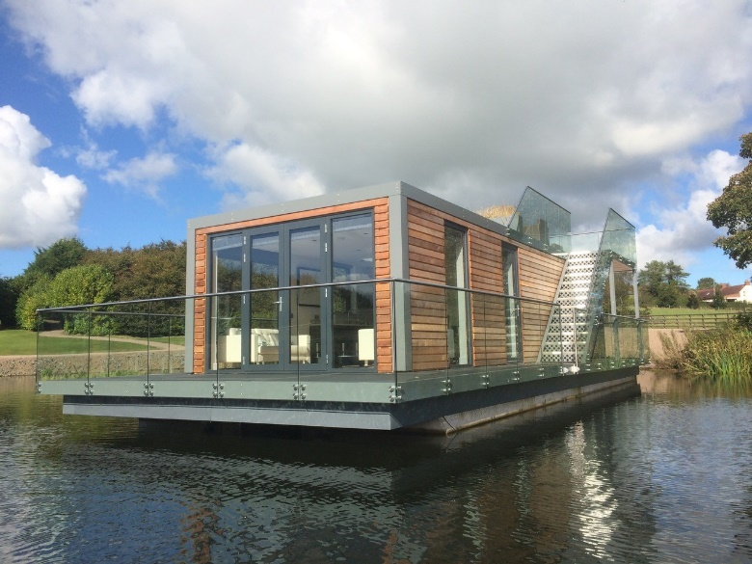
A floating home developed by Bluetech Waterfront solutions
Indeed, back in 2005, Dutch firm Dura Vermeer constructed several such houses in the village of Maasbommel along the Maas River. If the water levels rise, the houses do too, keeping their occupants dry. The houses float on hollow concrete and timber pontoons and sink back to their original position when floodwaters fall.
It’s a bold solution and clearly the idea of a floating home is not going to be for everyone. But there are other options. For example, on a development site at risk of relatively low levels of flooding, the ground could be contoured to channel flood water away from the homes.

“If in a development plot that is modelled to be at risk of relatively low levels of flood water, you do not have to build a flood-resilient house,” Pekbeken explains. “You could simply raise the homes, or you could adjust ground levels to balance where flood water goes compared to where a house goes.”
And for sites more at risk, other options still exist. “If you are looking at a development site which is wholly at flood risk, you could build homes that are built on stilts effectively,” says Perbeken.
You could build homes that go up and down that mean you do not displace any water off the site. The challenge, Floodline Consulting’s team has found, is not with the technical solution but with the reluctance of local authorities to permit its use. This, explains managing director Justin Meredith, is because government rules guide authorities towards the low-risk option through two key measures: the Sequential Test and the Exceptions Test.
The Sequential Test, set out in the government’s National Planning Policy Framework [NPPF], seeks to ensure that a sequential approach is followed to steer new development to areas with the lowest probability of flooding.
Through flood risk assessments, the aim of local planning authorities is to steer new development to Flood Zone 1, areas which the Environment Agency considers to have a probability of flooding of less than 1 in 1,000 years.

Where there are no reasonably available Flood Zone 1 sites, local authorities take into account reasonably available Flood Zone 2 designated sites. These are considered to have a flood risk of less than 1 in 100 years.

Only where there are no Zone 1 or 2 area is the suitability of high flood risk sites in Zone 3a considered. These areas have a high probability of flooding, at least 1 in 100 years. Zone 2 and 3a areas have a wide spectrum of flood risk, and Floodline believes there is the capacity to release such land which can be sustainably developed.

Sustainability versus flood risk
Meanwhile, the Exceptions Test, also set out in the NPPF, requires developers to show that any development will provide sustainability benefits that outweigh flood risk, and that a development will be safe for its lifetime, without increasing flood risk elsewhere while reducing overall flood risk.
But it is on the Sequential Test where Floodline Consulting appears to be coming most unstuck. Meredith explains: “The difficulty we have had is that an authority which is naturally nervous of encouraging development in a flood-risk area can use it to work it against us by saying ‘the NPPF does not say I have to consider the fact that your building has been designed for that area.

“All it says is I need to find somewhere with less risk of flooding, so you might be proposing your development in Flood Zone 2 or 3a, but if there is any land in Flood Zone, 1 then by definition you must fail the Sequential Test.”
Meredith accuses local authorities of applying an extremely black and white approach to the application of the Sequential Test, without feeling the need to be pragmatic.
Bluetech Waterfront Solutions works on developing floating homes. It has also accused local authorities of lacking understanding of the technology available when it comes to their application of planning policy.
Because people are not understanding of floating homes, it is very difficult to get planners on board
“The impression I get is that…you seem to be going through the hoops quite a lot. Because people are not understanding of floating homes it is very difficult to get planners on board,” says director Carl West.

One solution to the lack of pragmatism has been proposed by Mott MacDonald global practice leader for water resources and flooding Fiona Barbour.

She is arguing for a risk-based approach, very much in line with the Exceptions Test. This could unlock flood-prone brownfield sites for further development easing pressure on greenfield land.

“Generally, the approach is that you cannot build within a flood plain,” Barbour summarises. “My proposal is that while there is a general consensus that we should not be building on greenfield flood plains, I think we should take a different view when the flood plain is already developed,” she argues, explaining that there are homes and buildings on such sites that existed before current planning policies were put in place and are already likely to be at high flood risk – a risk that could be reduced through development. The status quo, meanwhile, leaves businesses and homeowners trapped in devaluing properties.

